**SQL Module 10 Challenge Worksheet**

The Challenge Activity for this module asks you to answer the questions below. Use this space to record your responses. Then save and submit this document to Canvas as instructed in your online classroom.

This challenge is going to test your ability to create wildcards, as well as clean and combine data. You will be wrapping up this lesson using the employee demo database for query building and data cleaning. Remember to go back and review any areas that you are unclear about before moving on through the challenge.

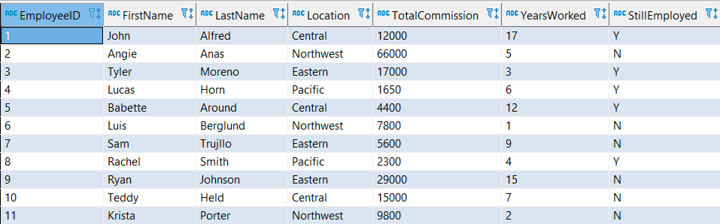

\*For a downloadable version of the database table, use the file provided in this Challenge in your online classroom.

Answer the following questions and queries, to successfully complete this challenge. Good luck!

**Instructions:** Follow the steps below to complete this challenge.

1. You want to combine the employee's first name and last name to create one column. Include an alias condition for EmployeeName. Using [myCompiler](https://www.mycompiler.io/new/sql) to complete the query below and include a space between each column:

Alternative Text: Image that shows a query with the following: 
SELECT ______(__________, "", __________) ____ EmployeeName
From employee

**Insert your SQL query here:   
SELECT concat(edd."FirstName",' ',edd."LastName") AS EmployeeName   
FROM employee\_demo\_database10 edd**

1. Create a query that will pull all records from the employeename column that start with the letters ‘ang’.

**[Insert your SQL query here.]   
  
SELECT EmployeeName  
FROM employee\_demo\_database10 edd   
WHERE EmployeeName ILIKE 'ang%'**

1. Create a query that will pull all records that include any value that has the characters ‘bet’.

**[Insert your SQL query here.] SELECT\*  
FROM employee\_demo\_database10 edd   
WHERE edd."FirstName" LIKE '%bet%'**

1. Create a query of all the employees who are in Central, Northwest, or Pacific locations using only one operator.

**[Insert your SQL query here.]   
SELECT edd."EmployeeID",edd."Location"   
FROM employee\_demo\_database10 edd   
WHERE "Location" IN ('Central','Northwest','Pacific')**

1. Create a query that will change location to all uppercase and call the new column ‘upperlocation’.

**[Insert your SQL query here.]   
SELECT upper(edd."Location") AS upperlocation  
FROM employee\_demo\_database10 edd**

1. Create a query that will remove all spaces from the beginning of the FirstName column. Call this column ‘firstnamenospaces’.

**[Insert your SQL query here.]   
SELECT ltrim(edd."FirstName") AS firstnamenospaces  
FROM employee\_demo\_database10 edd**

Challenge Questions

1. What wildcard will allow you to search for only specific characters within a value?

[Insert your response here.] \_. (Underscore)

1. What operator allows you to perform the same actions as the OR operator with less conditions?

[Insert your response here.] IN clause